***CDAC MUMBAI***

Concepts of Operating System

Assignment 1

**Problem 1: Read the instructions carefully and answer accordingly. If there is any need to insert some data then do that as well.**

**a) Navigate and List:**

a. Start by navigating to your home directory and list its contents. Then, move into a directory named "LinuxAssignment" if it exists; otherwise, create it.

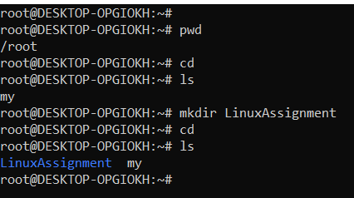

|  |
| --- |
| Go to Home Directory I use- cd |

|  |  |
| --- | --- |
| Check if "LinuxAssignment" is Exists - | `ls |

|  |  |
| --- | --- |
| Create "LinuxAssignment" with use of mkdir Linux Assingnment |  |

|  |  |
| --- | --- |
| Move into "LinuxAssignment"- ls  to check file - ls |  |

**b) File Management:**

a. Inside the "LinuxAssignment" directory, create a new file named "file1.txt". Display its contents.

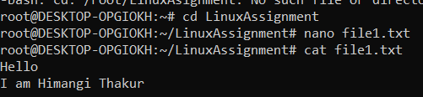

Go to LinuxAssignment - cd

Create a new file – nano file1.txt

Than insert text in file1 than press ctrl xy enter

Show file 1 content – cat file1. txt

**c) Directory Management:**

a. Create a new directory named "docs" inside the "LinuxAssignment" directory.

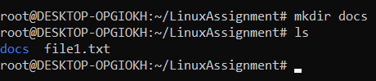

Create new file inside LinuxAssignment – mkdir docs

To inside Linux Assignment file is created – ls

**d) Copy and Move Files:**

a. Copy the "file1.txt" file into the "docs" directory and rename it to "file2.txt".

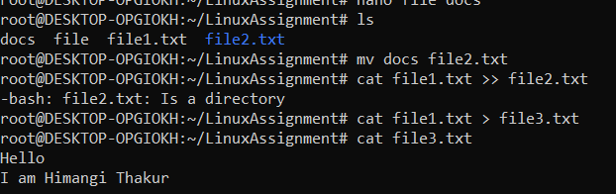

Check existing files – ls

Remave docs to file2.txt – mv docs file2.txt

File2.txt already exist and it’s a directory than

Copy file1.txt data to file2.txt – cat file1.txt >> file3.txt

Than check – cat file3.txt­­­­­­­­­­­

**e) Permissions and Ownership:**

a. Change the permissions of "file2.txt" to allow read, write, and execute permissions for the owner and only read permissions for others. Then, change the owner of "file2.txt" to the current user.

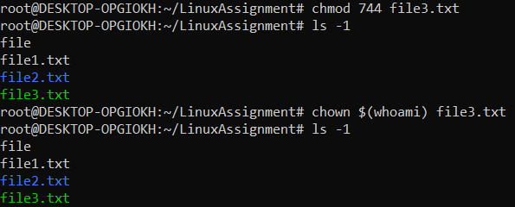

Change to full permissions for owner & read-only for others- chmod 744 file3.txt

To check – ls -1

Change Owner to current user – chown $(whoami) file3.txt

Than check - ls -1

**f) Final Checklist:**

a. Finally, list the contents of the "LinuxAssignment" directory and the root directory to ensure that all operations were performed correctly.

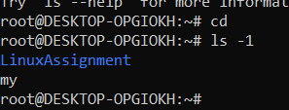

Go to file – cd

Check all operation – ls -1

**g) File Searching:**

a. Search for all files with the extension ".txt" in the current directory and its subdirectories.

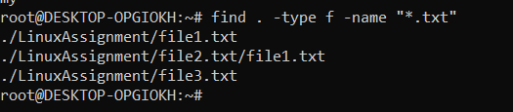

Search file – find

Search start from here - .

Look for file - -type f

Search with .txt - -name “*.txt”

b. Display lines containing a specific word in a file (provide a file name and the specific word to search).

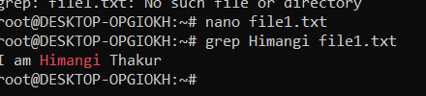

Find word in a file- grep “word which find” than file name.txt

**h) System Information:**

a. Display the current system date and time.

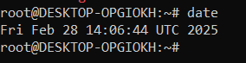

For display – date.

**i) Networking:**

a. Display the IP address of the system.



b. Ping a remote server to check connectivity (provide a remote server address to ping).

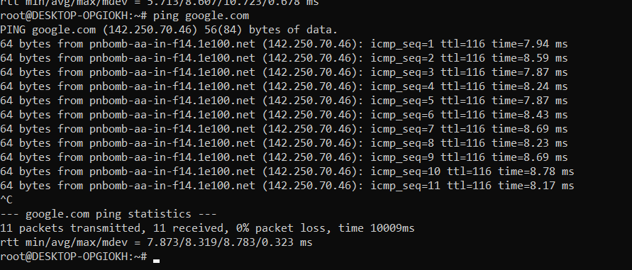

Check connectivity – ping servername

Than stop this press – ctrl c

**j) File Compression:**

a. Compress the "docs" directory into a zip file.

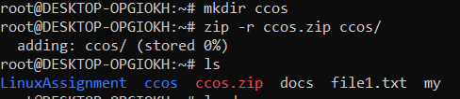

b. Extract the contents of the zip file into a new directory.

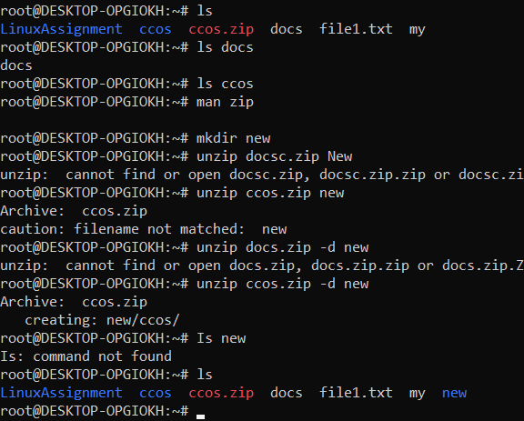

**k) File Editing:**

a. Open the "file1.txt" file in a text editor and add some text to it.

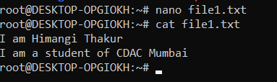

Open file – nano filename

Add some text than press ctrl+x y enter

Cat filename show text

Press window shift s for coping code picture

Press ctrl+v to paste it

b. Replace a specific word in the "file1.txt" file with another word (provide the original word and the word to replace it with).

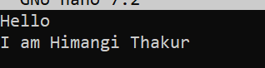 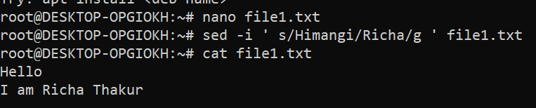

**Problem 2: Read the instructions carefully and answer accordingly. If there is any need to insert some data then do that as well.**

1. Suppose you have a file named "data.txt" containing important information. Display the first 10 lines of this file to quickly glance at its contents using a command.

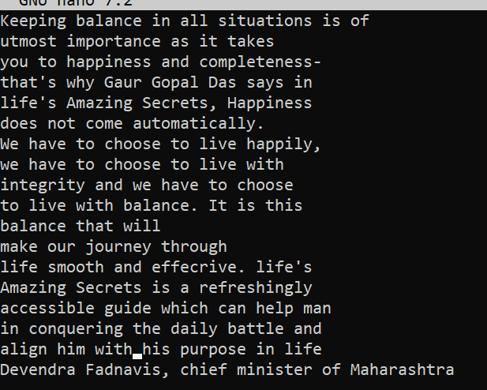



1. Now, to check the end of the file for any recent additions, display the last 5 lines of "data.txt" using another command.

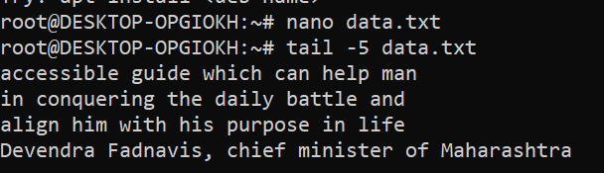

1. In a file named "numbers.txt," there are a series of numbers. Display the first 15 lines of this file to analyze the initial data set.

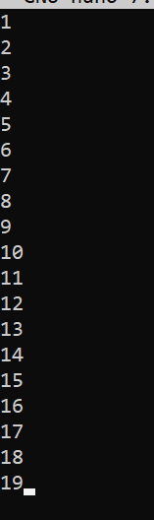

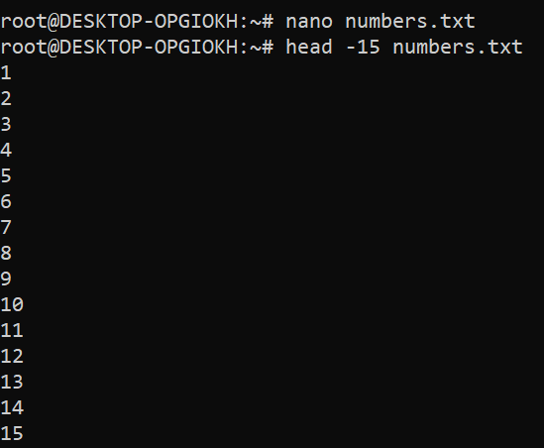

1. To focus on the last few numbers of the dataset, display the last 3 lines of "numbers.txt".

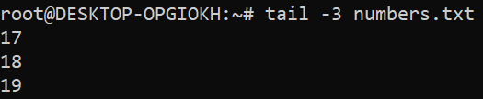

1. Imagine you have a file named "input.txt" with text content. Use a command to translate all lowercase letters to uppercase in "input.txt" and save the modified text in a new file named "output.txt."

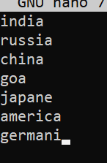 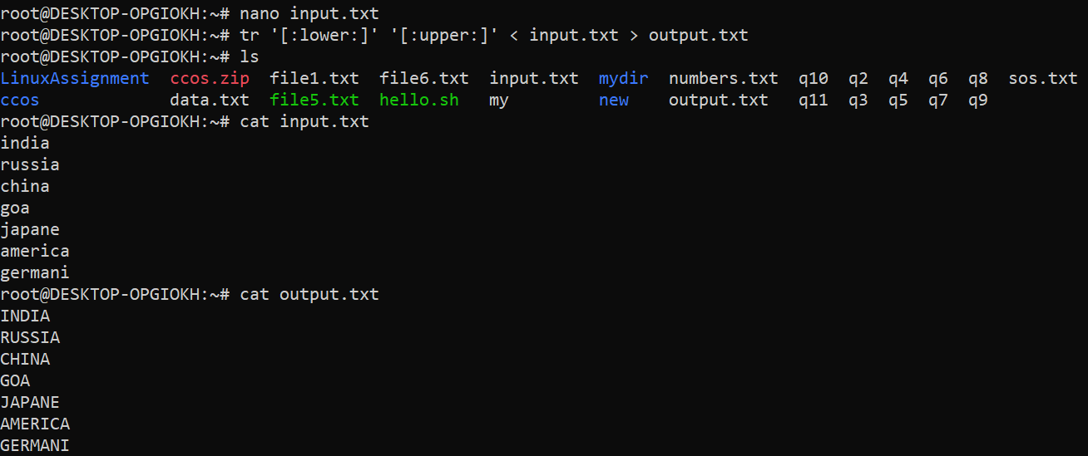

1. In a file named "duplicate.txt," there are several lines of text, some of which are duplicates. Use a command to display only the unique lines from "duplicate.txt."

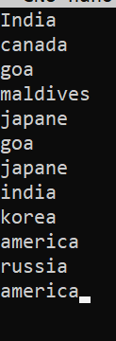 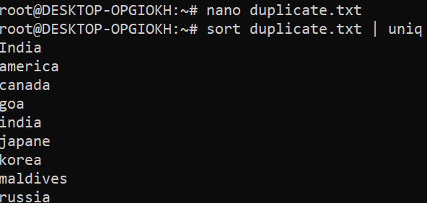

1. In a file named "fruit.txt," there is a list of fruits, but some fruits are repeated. Use a command to display each unique fruit along with the count of its occurrences in "fruit.txt."

